Lab 05

Collector Feedback Bias and Voltage Divider Bias BJT Biasing Configurations
Name: Syed M. Asad Ali  Hiba Aiman Ali  Syed Saad Imran | Student ID: sa09475  ha09269  sa09370

- Objective
To investigate the effect of current gain β variation on quiescent operating conditions of a Bipolar Junction Transistor in collector feedback bias and voltage divider bias configurations.
Note: Pre-lab (printed or hand-written) should be done on a separate paper (use A4 sheet) and will be submitted at the start of Lab within first 5 minutes.
All the plots to be attached, should be labeled properly, followed by Task number and must be readable, i.e., use white background, suitable marker color (recommended – any dark color) and increase the width of trace. On PSpice there is an option to add text labels in the plots.

- Introduction
In previous lab, the stability of fixed-bias and emitter-bias BJT biasing configurations have been investigated. In this lab, you will investigate the dependency of BJT operating point on DC current gain β for two more circuits of BJT biasing; collector feedback bias (with and without emitter resistor) and voltage divider bias configuration.

Pre-Lab Task

Task 1:
- List down two differences between 2N3904 and 2N4401 in terms of power rating and beta value.
3904 and 4401 has different β value, 3904 is better at low current and 4401 can handle higher current so it is better suited for higher power rating.
2N3904 can take upto 200mA while 2N4401 can take upto 500mA.

State advantages and disadvantages of the following transistor biasing configurations. Among these four which configurations is most used and why?
- Fixed Bias Configuration
- Common Emitter Bias configuration
- Collector Feedback Bias configuration
- Voltage Divider Bias configuration
- Advantages:
- Easy implementation
- Cost-effective as it requires less components
Disadvantages:
- Lack of stability due to temperature variations.

- Advantages:
- Better stability compared to fixed bias
Disadvantages:
- More complex than fixed bias
- Sensitive to temperature changes.
- Advantages:
- Improved stability over common emitter bias
- Better temperature compensation
- Higher reliability
Disadvantages:
- Slightly more complex than common emitter bias
- Advantages:
- Good stability and temperature compensation
- Suitable for various transistor applications
Disadvantages:
- More complex than fixed bias
- Increased power consumption

Most used: Voltage divider bias configuration
Why? The voltage divider bias configuration is commonly used because it offers a good glance between simplicity and stability. It provides better temperature compensation compared to fixed bias and common emitter bias configuration and can be used for a wide range of transistor applications.

- Collector Feedback Bias Configuration Without Emitter Resistor
Figure 1 shows BJT biasing through collector-feedback bias configuration. In this circuit, there is a feedback path from collector to base through a feedback resistor represented as R_{F}. The emitter terminal is directly grounded.
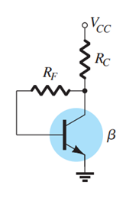
Figure 1: Collector-Feedback Bias configuration without emitter resistor
It is important to note here that the current through R_{C} is not I_{C}, but I_{C}’ (where, I_{C}’= I_{C} + I_{B}). Since, base current is small as compared to collector current, therefore, the approximation (I_{C}’$≅$ I_{C}) is normally applied. The analysis of the circuit can be performed by writing KVL equations for base-emitter and collector emitter loop.
The feedback path results in a reflection of the resistance R_{C} back to the input circuit, much like the reflection of R_{E} in emitter-bias circuit. Similarly, for collector-emitter loop, KVL equation gives;

Task 2: To bias 2N3904 and 2N4401 BJT models using Collector Feedback Bias configuration circuit without R_{E}
- Implement the circuit shown in Figure 1 to bias 2N3904 BJT with V_{CC}=20V, R_{C} = 3kΩ and R_{F}= 390kΩ.
- Measure the parameters listed in Table 1.
Table 1: Results of BJT biasing with collector-feedback biasing circuit without emitter resistor
Parameter | Results
 | 2N3904 | 2N4401
Base Current: I_{B} | 13.51 µA | 16.3 µA
Collector Current: I_{C} | 3.90 mA | 4.23 mA
Collector-to-Emitter Voltage: V_{CE} | 8.2V | 7.18V
Current Gain: β (calculated) | 288.67 | 259.51
Base-to-Emitter Voltage: V_{BE} | 0.69V | 0.65V
Measured resistances | Rc = 2.94 kΩ | Rf = 385.9 kΩ
- Now, replace the BJT model 2N3904 by 2N4401 model in the same circuit and take measurements to complete Table 1.

Task 3: To investigate effect of current gain β variation on BJT operating point with collector feedback-bias configuration circuit without R_{E}
- When biased using collector feedback-bias circuit, analyze the variation in operating point of BJTs as the DC current gain varies from the results of Table 1.
The variation in operating points is significant as Ic and values differ because of the variation in DC current gain.
- Calculate the percentage change in parameters listed in Table 4 using the results of Task 1.

- Collector Feedback Bias Configuration with Emitter Resistor
In the collector-feedback biasing configuration of Figure 1, a resistor at emitter R_{E} is added as shown in Figure 2, that modifies the equations for base current and collector-emitter voltage as follows;
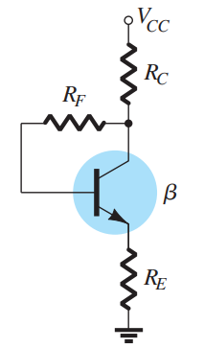
Figure 2: Collector-feedback circuit with emitter resistor

Task 4: To bias 2N3904 and 2N4401 BJT models using Collector Feedback Bias configuration circuit with R_{E}
- Modify the implemented circuit to include emitter resistor R_{E} of 2.2 kΩ. Again, take the measurements for the specified BJT models (2N3904 and 2N4401) and note down in Table 2.

Table 2: Results of BJT biasing with collector-feedback biasing circuit having emitter resistor
Parameter | Results
 | 2N3904 | 2N4401
Base Current: I_{B} | 11.2 µA | 13.43 µA
Collector Current: I_{C} | 3.62 mA | 3.77mA
Collector-to-Emitter Voltage: V_{CE} | 3.53 V | 3.22 V
Current Gain: β (calculated) | 323.21 | 280.71
Base-to-Emitter Voltage: V_{BE} | 0.65 V | 0.62 V
Measured Resistance | Rc = 2.94 kΩ  Rf = 385.9 kΩ  Re = 2.16 kΩ | Rc = 2.94 kΩ  Rf = 385.9 kΩ  Re = 2.16 kΩ

Task 5: To investigate effect of current gain β variation on BJT operating point with collector feedback-bias configuration circuit with R_{E}
- After addition of emitter resistor, analyze the variation in operating point of BJTs as the DC current gain varies from the results of Table 2. Compare it with the case when emitter was directly grounded. Using the expressions of base-current for each case, relate the effect of emitter resistor on the BJT operating point.
The variation in DC current is still there but Ic varies less slightly than before because of the resistor connected to emitter.

- Calculate the percentage change in parameters listed in Table 4 using the results of Task 3.
- Voltage-Divider Bias Configuration
The circuit shown in Figure 3 is called Voltage-Divider bias configuration as a voltage divider circuit using resistors R1 and R2 is implemented to establish base voltage. There are two approaches to analyze the circuit, the exact and the approximate one. Here, approximate one is used for analysis.
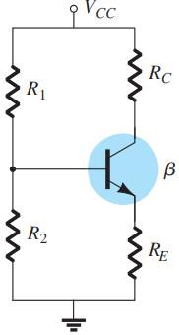
Figure 3: Voltage-Divider Bias Configuration
For the circuit to operate efficiently, it is assumed that the current through R1 and R2 should be approximately equal to and much larger than the base current (at least 10:1). If the biasing circuit fulfills the condition, then
Base voltage can be then expressed as:
Similarly, the collector-to-emitter voltage can be expressed as:

Task 6: To bias 2N3904 and 2N4401 BJT models using Voltage Divider Bias configuration circuit
- Implement the circuit shown in Figure 3 to bias 2N3904 BJT model with V_{CC}= 20V, R1= 33kΩ, R2= 6.8kΩ , R_{C} = 1.8kΩ and R_{E}= 680 Ω.
- Take the measurements for parameters listed in Table 3.
- Now, replace 2N3904 BJT model by 2N4401 and complete the measurements for Table 3.
Table 3: Results of BJT biasing through voltage-divider bias configuration
Parameter | Results
 | 2N3904 | 2N4401
Base Current: I_{B} | 13.03 µA | 15.1 µA
Collector Current: I_{C} | 3.98 mA | 3.94 mA
Collector-to-Emitter Voltage: V_{CE} | 10.39 V | 10.22 V
Current Gain: β (calculated) | 305.4 | 260.2
Base-to-Emitter Voltage: V_{BE} | 0.67 V | 0.64 V
Measured Resistances | R1= 33.3 kΩ  R2 = 6.81 kΩ  Rc= 1.78 kΩ  Re = 670 Ω | R1= 33.3 kΩ  R2 = 6.81 kΩ  Rc= 1.78 kΩ  Re = 670 Ω

Task 7: To investigate effect of current gain β variation on BJT operating point with Voltage-Divider Bias configuration circuit
- Using the results of Table 3, analyze the effect of DC current gain variation on the operating point of BJT when it is biased using voltage-divided bias circuit.
In voltage-divider bias configuration, variation in DC current has negligible effect of an Ic and Vce which means that β has almost no effect on the operating point of the BJT.
- Calculate the percentage change in parameters listed in Table 4 using the results of Task 5.
Table 4: Variation in operating point compared with change in DC current gain for different biasing circuits
Percentage Change in Parameters | Collector Feedback Bias without R_{E} | Collector Feedback Bias with R_{E} | Voltage-Divider Bias
% $∆$β = | 10.10% | 13.15% | 14.8%
% $∆$I_{C} = | 8.46% | 4.14% | 1.005%
% $∆$V_{CE} = | 12.44% | 8.78% | 1.66%
% $∆$I_{B} = | 20.65% | 19.91% | 15.89%

Task 8: To compare the stability of BJT biasing configurations
- Using results of Table 4, compute the stability factors for each of the implemented biasing techniques. Note down the results of fixed-bias and emitter-bias circuits from previous lab to complete Table 5.

Table 5: Stability factors of different BJT biasing techniques w.r.t. the variation in DC current gain
Biasing Configuration
Fixed-Bias (Lab 04) | 1 | 4.46
Emitter-Bias (Lab 04) | 0.638 | 2.2
Collector-Feedback Bias without R_{E} | 0.838 | 1.232
Collector-Feedback Bias with R_{E} | 0.315 | 0.668
Voltage-Divider Bias | 0.068 | 0.112
- Compare the performance of BJT biasing techniques using the above calculated performance parameters. What does the magnitude of calculated ratio signify? Which of the 5 investigated circuits can be regarded as β independent circuit?
The voltage divider can be regarded as a β independent circuit because the change in Ic and Vce with respect to change in the value of β is very small that its effect can be safety ignored.

- Post-Lab Task

Task 9: To design voltage-divider BJT biasing circuit for given operating point
Design a voltage-divider BJT biasing circuit to make BJT 2N3904 operate at the operating point given in Lab 04 (Task 6) where, the required collector current I_{C} was 2mA and collector-to-emitter voltage V_{CE} was 10V.
Use 20V supply voltage, DC current gain of 150 and select the conservative case of emitter voltage being one-tenth of the supply voltage in your design calculations. For design, you may use approximate analysis for which equations are given in section 5.6. Show all the calculations.

Simulate your designed circuit.

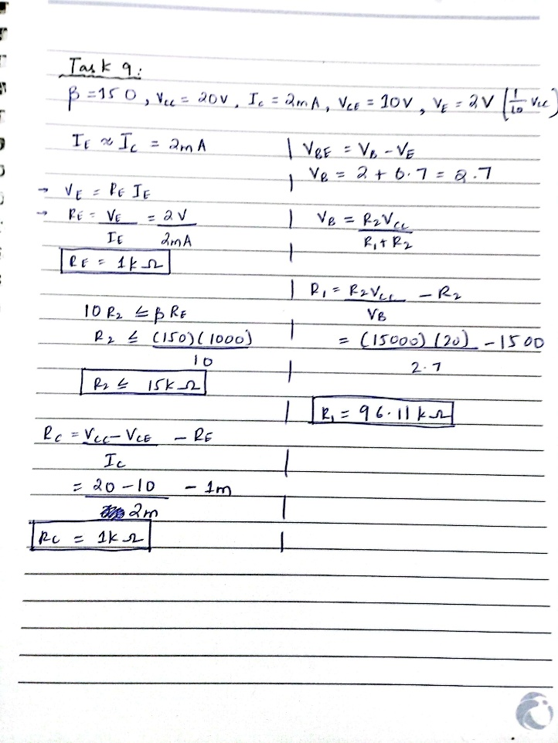
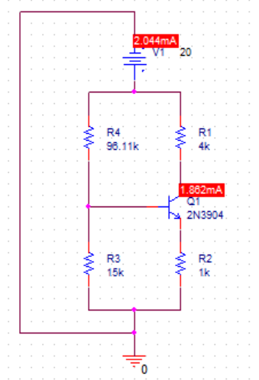
The values are very close to what we expected, Ic = 1.826mA, and it should have been 2mA ideally and Vce is just above 10V and should also have been 10V ideally, so the Q point we took is ideal and working properly.
Assessment Rubric
Lab 05
Collector Feedback Bias and Voltage Divider Bias BJT Biasing Configurations
Name: | Student ID:

Points Distribution

Task No. | LR1  Circuit | LR2  Simulation | LR 4  Data Collection | LR 6  Calculation | LR 10  Analysis | LR 11  Design
Task 1 |  |  | /10
Task 2 | /4 |  | /4 | /2
Task 3 |  |  |  | /4 | /4
Task 4 | /4 |  | /4 | /2
Task 5 |  |  |  | /4 | /4
Task 6 | /4 |  | /4 | /2
Task 7 |  |  |  | /4 | /4
Task 8 |  |  |  | /4 | /8
Task 9 |  | /6 |  |  |  | /12
 | /12 | /6 | /22 | /22 | /20 | /12
CLO Mapped | CLO 1 | CLO1 | CLO 1 | CLO 1 | CLO 1 | CLO 2

Affective Domain Rubric |  | Points | CLO Mapped
AR4 | Pre-Lab Submission | /2 | CLO 4
AR 4 | Report Submission | /4 | CLO 4

CLO | Total Points | Points Obtained
1 | 82
2 | 12
4 | 06
Total | 100

For description of different levels of the mapped rubrics, please refer the provided Lab Evaluation Assessment Rubrics and Affective Domain Assessment Rubrics.

